Benford's law

Alias

Benford’s law

Newcomb-Benford's law

Intro

Newcomb-Benford's law is the law of anomalous numbers. It is an observation that the leading data of sets of numerical data used in many real life is likely to be small.

Def

With base 10 of logarithm

Probability satisfies Newcomb-Benford’s law if the set of numbers of leading digit $$d$$ (i.e. $$d$$ belongs to $$\left\{1,2,…,9\right\}$$) with probability as follows:

$$P\left(d\right)$$

= $$\log\left(d+1\right)−\log\left(d\right)$$

With the above formula, the distribution shows as follows table.

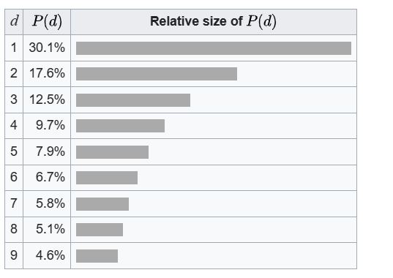

With base b of logarithm

$$\log_{b}\left(d+1\right)−\log_{b}\left(d\right)$$

where

$$b>0$$ and $$b !=1$$ by domain of logarithm.

Application

It can be applied at least in these application. For explanation, see Wiki in Ref section.

Accounting fraud detection

Criminal trials

Election data

Macroeconomic data

Price digit analysis

Genome data

Scientific fraud detection

Ref

[Benford's law - Wikipedia](https://en.wikipedia.org/wiki/Benford%27s_law)